**Importing Files from a Local Folder**

**Demonstration steps**

Import Data from an Excel File

1. On the taskbar, click **Power BI Desktop**.
2. If the **Sign into your account** dialog box appears, enter the credentials you used to sign up for Power BI service, and then click **Sign in**.
3. In the **Power BI Desktop** window, click **Get Data**.
4. In the **Get Data** dialog box, click **Excel**, and then click **Connect**.
5. In the **Open** dialog box, navigate to **C:\Demofiles\Mod03\Demo\Files for Import**, click **Sales.xlsx**, and then click **Open**.
6. In the Navigator window, click **Sales** to show a preview of the data. Use the horizontal scrollbar to display the columns, select the **Sales** check box, and then click **Load**.
7. When the load completes, in the **Fields** pane, point out the **Sales** table. Mention that Power BI has detected columns that can be used in aggregations, as indicated by the **Sum** symbol next to the column names.
8. Select City, Country, Order Quantity and Total Due
9. It will generate map chat automatically

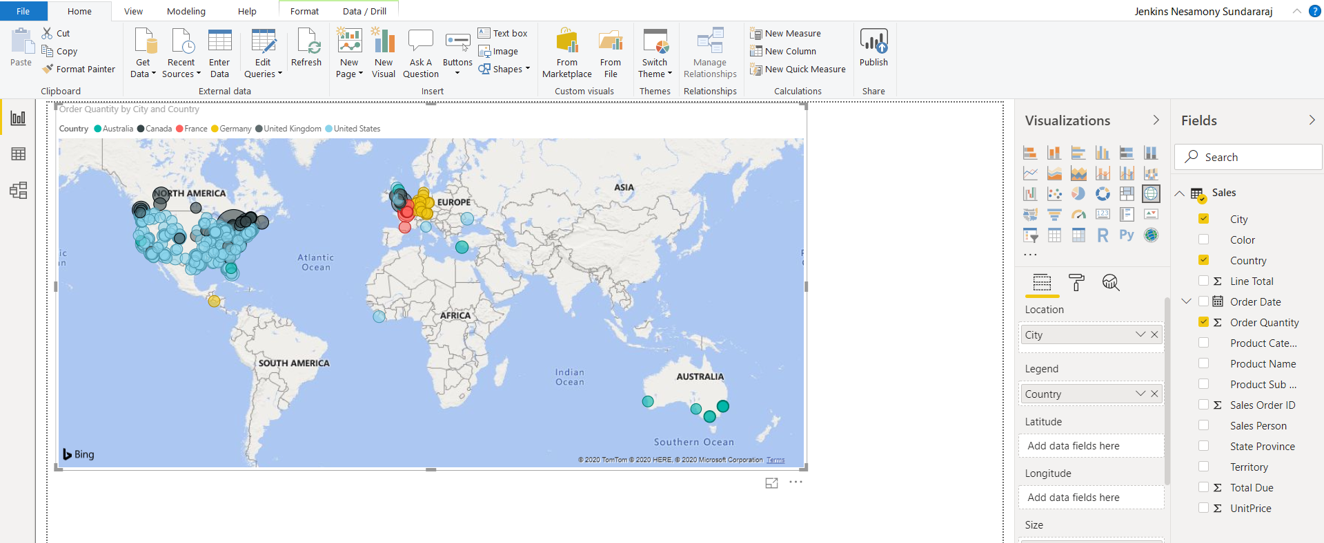

Import Data from a CSV File

1. On the **Home** ribbon, click **Get Data**.
2. In the **Get Data** dialog box, click **Text/CSV**, and then click **Connect**.
3. In the **Open** dialog box, navigate to **C:\Demofiles\Mod03\Demo\Files for Import**, click **SalesPerson.csv**, and then click **Open**.
4. In the preview window, drag the lower-right corner to enlarge the window and display more of the data.
5. Click **Load**.
6. In the **Fields** pane, expand the **SalesPerson** table to show the columns. Mention that the two tables from different sources are now available to use together in a report. If the report is published, the tables will be part of the same dataset.
7. Select First Name and Last Name to create a table chat
8. Select City, Country, Sales last year and Sales YTD it will create a map chat
9. On the **File** menu, click **Save As**, name the report **Adventure Works Sales**, and then save to the **C:\Demofiles\Mod03\Demo** folder.
10. Leave Power BI open for the next demonstration

